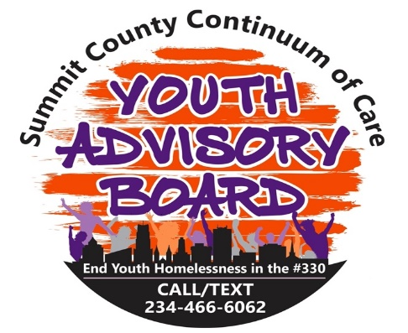

**Youth Advisory Board By-Laws**

**Article I. Name**

The name of this group is the Youth Advisory Board.

**Article II. Mission Statement**

The YAB is a body of young people ages 24 and under that inform and advise policies and practices that directly impact young people experiencing homelessness in Summit County. Members of the board share their own personal experiences which help shape systems and services to be efficient and effective.

**Article III. Non-Discrimination Policy**

* The Youth Advisory Board does not discriminate nor tolerate discrimination on the basis of religion, race, color, ethnicity, sex, sexual orientation, gender identities, disabilities, size, political beliefs, or religion.
* **THE YAB IS A SAFE SPACE FOR THE MEMBERS AND THE YOUTH WE SERVE. WE ARE EXPECTING THE MEMBERS TO TREAT EVERYONE WITH RESPECT AND TO BE DEDICATED TO HELPING YOUTH IN SUMMIT COUNTY.**

**Article III. Conduct**

Every member of the Youth Advisory Board must conduct themselves in a positive manner and treat everyone they encounter with respect. The YAB is a safe space for everyone to feel safe and comfortable, we do not permit weapons of any kind at our meetings and activities. We also encourage not to attend any events while under the influence of drugs or alcohol.

**Article IV. Membership**

The YAB must have at least 5 members comprised of youth who are 24 years old and under, and at least 2/3 of whom are homeless or formerly homeless.

**Article V. Youth Advisory Board Officers**

1. The YAB Chair shall be a member of the community elected by fellow Youth Advisory Board members. The Chair, who shall be a voting member of the SCCoC Board of Trustees, and their duties shall include but not be limited to the following: a) Assist in the development and implementation of the SCCoC strategy using subcommittees and workgroups; b) Develop and train on youth-related policies, procedures, outcome expectations, and reporting tools; and c) Report activities to the Board of Directors.
2. The Vice-Chair will act in place of the Chair if/when the Chair is unavailable to facilitate meetings.
3. The Secretary will take the minutes of every monthly YAB meeting and Executive Board meetings; the Executive Board consists of all YAB officers. The Secretary is also responsible for distributing general correspondence to the membership and keeping a record of monthly meeting attendance.
4. The Social Media Chair shall work under the direction of the Youth Coordinator to post YAB and youth-specific items on the YAB website and all the YAB media platforms.
5. The Youth Events Coordinator leads in the planning and execution of any YAB activities outside of monthly meetings, i.e., the annual cookout and Jingle& Mingle. This position also works under the direction of the membership and the Youth Coordinator.

**Decision Making & Management Structure**

The Board will use a voting process to make decisions. A simple majority of present Board members shall constitute approval of any motion before the Board.

Quorum: A majority of the members shall constitute a quorum at a meeting of the members. If less than a quorum is represented at a meeting, the members present hold the right to discuss the business of the meeting at hand, but no voting can occur until a quorum may be assembled. Should the votes be evenly split, the co-chairs shall cast the deciding vote.

Please find Youth Advisory Board Governance attachment

**Article VIII. Meetings**

All meetings are held on the last Thursday of every month. Additional meetings can be scheduled when voted upon and agreed upon by a simple majority of the Executive Committee.

**Article IX. Compensation**

The YAB members will be receiving compensation in the form of Cashapp or gift cards per YAB members choice. Authentic Action and Engagement Beyond YHDP: The YAB is funded by both the SCPH ODH grant and the YHDP Planning grant and carries out both YHDP and CoC-related work. Roles taken on by the YAB include providing input of project implementation; crafting language and review of RFPs for subcontracts; and drafting recruitment notices and sitting on hiring panels for openings in projects serving youth experiencing homelessness. The YAB is a vital partner in carrying out a comprehensive community approach to preventing and ending youth homelessness, including but beyond the YHDP.