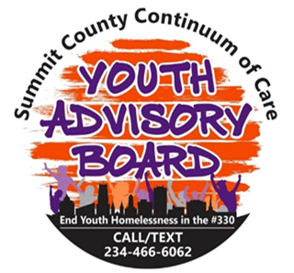
CashApp Policy
Before any payments can be issued via CashApp by the Summit County Continuum of Care (SCCoC), all participants must complete and sign a stipend contract and a W-9 form. These documents are mandatory to ensure proper documentation and compliance with payment regulations.

Payment for Monthly In-Person Meetings
Individuals who attend the monthly in-person SCCoC meeting will be compensated at a rate of $21.00 per hour. Payments will be processed via CashApp immediately following the meeting, provided the attendee has completed and signed their timesheet at the end of the session.

Payment for YHDP and YHSI Meetings
For those who also participate in Youth Homelessness Demonstration Program (YHDP) and Youth Housing Stability Initiative (YHSI) meetings, compensation will similarly be at a rate of $21.00 per hour. The Youth Coordinator will be responsible for tracking attendance at these meetings. Payments for YHDP and YHSI participation will be processed via CashApp after the last event/meeting of each month, contingent upon the completion and signing of timesheets.

